Ideation Phase

Define the Problem Statements

Problem Statement :

Due to the ignorance of healthy food habits, obesity rates are increasing at an alarming speed, and this is reflective of the risks to people’s health. People need to control their daily calorie intake by eating healthier foods, which is the most basic method to avoid obesity. However, although food packaging comes with nutrition (and calorie) labels, it’s still not very convenient for people to refer to App-based nutrient dashboard systems which can analyze real-time images of a meal and analyze it for nutritional content which can be very handy and improves the dietary habits, and therefore, helps in maintaining a healthy lifestyle.

Example:

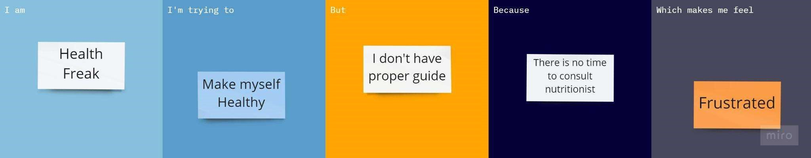

|  |  |  |  |  |  |
| --- | --- | --- | --- | --- | --- |
| Problem  Statement (PS) | I am  (Health  Freak) | I’m trying to | But | Because | Which makes me feel |
| PS-1 | Concern about my health | Make myself healthy | I can’t consult any nutritionist | I don’t have time | Frustrated |